**STUDENT MANAGEMENT SYSTEM**

**A PROJECT REPORT**

**for**

**Mini Project (KCA353)**

**Session (2023-24)**

**Submitted by**

**PEEYUSH TYAGI**

**2200290140108**

**NITISH KUMAR GUPTA**

**2200290140102**

**Submitted in partial fulfilment of the**

**Requirements for the Degree of**

**MASTER OF COMPUTER APPLICATION**

**Under the Supervision of**

**DR. AMIT KUMAR GUPTA**

### PROFESSOR



**Submitted to**

**Department Of Computer Applications**

**KIET Group of Institutions, Ghaziabad**

**Uttar Pradesh-201206**

**(January 2024)**

**CERTIFICATE**

Certified that **Peeyush Tyagi 2200290140108, Nitish Kumar Gupta 2200290140102** have carried out the project work having “**Student Management System**” (**Mini Project-KCA353**) for **Master of Computer Application** from Dr. A.P.J. Abdul Kalam Technical University (AKTU**)** (formerly UPTU), Lucknow under my supervision. The project report embodies original work, and studies are carried out by the student himself/herself and the contents of the project report do not form the basis for the award of any other degree to the candidate or to anybody else from this or any other University/Institution.

**Date:**

**Peeyush Tyagi 2200290140108**

**Nitish Kumar Gupta 2200290140102**

This is to certify that the above statement made by the candidate is correct to the best of my knowledge.

Date:

**Dr. Amit Kumar Gupta Dr. Arun Tripathi**

**Professor Head**

**Department of Computer Applications Department of Computer Applications**

**KIET Group of Institutions, Ghaziabad KIET Group of Institutions, Ghaziabad**

**Student Management System**

**Peeyush Tyagi, Nitish Kumar Gupta**

**ABSTRACT**

The main objective of this project is to build a student database system that will store records of students. It is purposed to reduce time spent on administrative tasks. The system is intended to accept process, generate students. The system is also intended to provide better services to users, provide meaningful, consistent, and timely data and information and finally promotes efficiency by converting paper processes to electronic form. The system was developed using basic technologies such as MySQL database and PHP. The system is free of errors and very efficient and less time consuming due to the care taken to develop it. All the phases of software development cycle are employed and it is worthwhile to state that the system is user friendly and strong. Provision is made for future development in the system. Furthermore, rigorous testing procedures have been implemented to ensure the system's reliability and accuracy. User feedback and iterative refinement have contributed to its user-centric design, resulting in a seamless experience for administrators and other stakeholders. The system's adaptability and scalability lay a strong foundation for future enhancements, promising continued efficiency gains and improved administrative workflows. Overall, this project represents a significant step towards modernizing student data management processes, paving the way for enhanced productivity and service delivery in educational institutions. Additionally, the system incorporates robust security measures to safeguard sensitive student data, ensuring compliance with privacy regulations and bolstering trust among users. Through its intuitive interface and efficient data processing capabilities, the system empowers administrators to focus more on strategic initiatives rather than routine administrative tasks. Its successful deployment underscores the importance of leveraging technology to optimize educational operations, paving the way for a more streamlined and responsive administrative framework. As technology continues to evolve, the system remains poised to adapt and evolve, serving as a cornerstone for ongoing improvements in student management processes.

**ACKNOWLEDGEMENTS**

Success in life is never attained single-handedly. My deepest gratitude goes to my project supervisor, **Dr. Amit Kumar Gupta** for his guidance, help, and encouragement throughout my project work. Their enlightening ideas, comments, and suggestions.

Words are not enough to express my gratitude to Dr. Arun Kumar Tripathi, Professor and Head, Department of Computer Applications, for his insightful comments and administrative help on various occasions.

Fortunately, I have many understanding friends, who have helped me a lot on many critical conditions.

Finally, my sincere thanks go to my family members and all those who have directly and indirectly provided me with moral support and other kind of help. Without their support, completion of this work would not have been possible in time. They keep my life filled with enjoyment and happiness.

**Peeyush Tyagi**

**Nitish Kumar Gupta**

**TABLE OF CONTENTS**

|  |  |  |  |  |
| --- | --- | --- | --- | --- |
|  | Certificate | | | ii |
|  | Abstract | | | iii |
|  | Acknowledgements | | | iv |
|  | Table of Contents | | | v |
|  | List of Tables | | | vii |
|  | List of Figures | | | viii |
| 1 | Introduction | | | 1-4 |
|  | 1.1 | | Overview | 1 |
|  | 1.2 | | Purpose | 1 |
|  | 1.3 | | Advantages | 1-2 |
|  | 1.4 | | Disadvantages | 2-3 |
|  | 1.5 | | Applications | 3 |
| 2 | System Requirements | | | 4-7 |
|  | 2.1 Feasibility Study | | | 4-5 |
|  | 2.2 Scope of the Project | | | 5 |
|  | 2.3 Functional Requirements | | | 5-6 |
|  | 2.4 Software and Hardware Requirements | | | 6-7 |
| 3 | Design | | | 8-15 |
|  | 3.1 | | Unified Modelling Language Diagram | 8-9 |
|  | 3.2 | | Use Case Diagrams | 9-11 |
|  |  | | 3.2.1 User/ Student | 10 |
|  |  | | 3.2.2 Admin | 11 |
|  | 3.3 | | E-R Diagram | 12 |
|  | 3.4 | | Database Design | 13-14 |
|  | 3.5 | | Class Diagram | 15 |
| 4 | Testing | | | 16-18 |
|  | 4.1 | Unit Testing | | 16 |
|  |  |  | |  |
|  | 4.2 | Integration Testing | | 17 |
|  | 4.3 | System Testing | | 17 |
|  | 4.4 | Acceptance Testing | | 18 |
|  | 4.5 | Debugging | | 18 |
| 5 | Results | | | 19-28 |
|  | 5.1 | Screens | | 19-28 |
| 6 | Discussions | | | 29-32 |
|  | 6.1 | Performance | | 29 |
|  | 6.2 | Limitations of the System | | 29-30 |
|  | 6.3 | Future Research Directions | | 31-32 |
| 7 | Conclusion | | | 33 |
| 8 | Bibliography | | | 34 |

9 References 35

**LIST OF TABLES**

|  |  |  |
| --- | --- | --- |
| **Table No.** | **Name of Table** | **Page** |
| 3.1 | tbladmin Structure | 13 |
| 3.2 | tblclass Structure | 13 |
| 3.3 | tblnotice Structure | 13 |
| 3.4 | tblpublicnotice Structure | 14 |
| 3.5 | tblstudent Structure | 14 |
| 3.6 | tblpage Structure | 14 |
|  |  |  |
|  |  |  |
|  |  |  |
|  |  |  |
|  |  |  |

**LIST OF FIGURES**

|  |  |  |  |
| --- | --- | --- | --- |
| **Figure No.** | **Name of Figure** | **Page No.** | |
| 3.1 | Use Case Diagram for User | | 9 | |
| 3.2 | Use Case Diagram for Admin | | 10 | |
| 3.3 | E-R Diagram | | 11 | |
| 3.4 | Class Diagram | | 14 | |
| 5.1 | Home Page | | 18 | |
| 5.2 | About Us | | 19 | |
| 5.3 | Login Page | | 19 | |
| 5.4 | Admin Dashboard | | 20 | |
| 5.5 | View and Add Teacher | | 20 | |
| 5.6 | View and Add Student | | 21 | |
| 5.7 | View and Add Grade by Admin | | 21 | |
| 5.8 | View and Add Class | | 22 | |
| 5.9 | View and Add Notices | | 22 | |
| 5.10 | Edit Course | | 23 | |
| 5.11 | Student Dashboard | | 23 | |
| 5.12 | Grade Summary | | 24 | |
| 5.13 | Change Student Password | | 24 | |
| 5.14 | Teacher Dashboard | | 25 | |
| 5.15 | View Classes | | 25 | |
| 5.16 | View Student | | 26 | |
| 5.17 | View Student Grades | | 26 | |
| 5.18 | Change Password for Teacher | | 27 | |
|  |  | |  | |

**CHAPTER 1**

**INTRODUCTION**

* 1. **Overview**

Student Management System is software which is helpful for students as well as the school authorities. In the current system all the activities are done manually. It is very time consuming and costly. Our Student Management System deals with the various activities related to the students. The two main users involved in this system are

1. User (i.e., Students)

2. Admin

In the Software we can register a student by the authentication code i.e., student id and password with help of student id and password student can login his/her account and view all the notices which is announced by admin

* 1. **Purpose**

The objective of Student Management System is to allow the administrator of any organization to edit and find out the personal details of a student and allows the student to keep up to date his profile. It’ll also facilitate keeping all the records of students, such as their id, name, mailing address, phone number, DOB etc. So, all the information about a student will be available in a few seconds. Overall, it’ll make Student Information Management an easier job for the administrator and the student of any organization.

* 1. **Advantages**

The Student Management System has the following advantages:

* It helps the educational administrator to handle and manage students’ records.
* It helps educational administrator to generate report.
* It brings transparency and efficiency in the working of educational system
  1. **Disadvantages**

The disadvantages of the Student Management System are :

* The system can only handle single educational organization.
* The system does not include bank payment, dd, cheque status
  1. **Applications**

The website Student Management System is aimed towards recording a considerable

number of student’s records and needs online assistance for managing records of students. Website should be user-friendly, ‘quick to learn’ and reliable website for the above purpose. Student Management System is intended to be a stand-alone product and should not depend on the availability of another website. The system will also have an administrator who has full- fledged rights with regards to performing all actions related to control and management of the website.

**CHAPTER 2**

**SYSTEM REQUIREMENTS**

**2.1 Feasibility Study**

Whenever we design a new system, normally the management will ask for a feasibility report of the new system. The management wants to know the technicalities and cost involved in creation of new system.

* Technical feasibility
* Economic feasibility
* Physical feasibility

**2.1.1 Technical Feasibility**

Technical feasibility involves study to establish the technical capability of the system being created to accomplish all requirements to the user. The system should be capable of handling the proposed volume of data and provide users and operating environment to increase their efficiency. For example, system should be capable of handling the proposed volume of data and provide users.

**2.1.2 Economical Feasibility**

Economic feasibility involves study to establish the cost benefit analysis.

Money spent on the system must be recorded in the form of benefit from the system. The benefits are of two types:

* **Tangible benefits:**

Saving man labor to do tedious tasks saves time.

* **Intangible benefits:**

Improves the quality of organization.

**2.1.3 Physical Feasibility**

It involves study to establish the time responses of the new system being created. For e.g., if the new system takes more than one day to prepare crucial finance statement for the management, wherever it was required in an hour, the system fails to provide the same.

It should be clearly established that the new system requirements in the form of time responses would be completely met with. It may call for increase in cost. If the required cost is sacrificed then the purpose of the new system may not be achieved even if it was found to be technically feasible

**2.2 Scope of the Project**

The proposed system will affect or interface with the user (student) and administrator. The system works and fulfills all the functionalities as per the proposed system. It will provide reduced response time against the queries made by different users. This project is based on HTML, CSS, JavaScript, PHP language with MySQL database which manage the details of the student because it is a tedious job for any organization. Student Information system will store all the details of the students including their background information.

All possible features such as verification, validation, security, user friendliness etc. have been considered.

**2.3 Functional Requirements**

he different types of modules present in this project are

1.

Admin

2.

User

The different types of modules present in this project are

* Admin
* User

**2.3.1 Admin**

* **Dashboard:** In this section, admin can see all detail in brief like Total Classes, Total Students, Total Class Notices and Total Public Notices.
* **Class:** In this section, admin can manage class (Add/Update/Delete).
* **Students:** In this section, admin can manage the students (Add/Update/Delete).
* **Notices**: In this section, the admin can manage notices (Add/Update/Delete).
* **Public Notices:** In this section, the admin can manage public notices.
* **Pages:** In this section admin, can manage about us and contact us page of administration
* **Search:** In this section admin, can search students by their student id.
* **Reports:** In this section admin, can view how much students has been register in particular period.
* Admin can also update his profile, change the password and recover the password.

**2.3.2 User (Students)**

* **Dashboard**: It is welcome page for students.
* **View Notices**: In this section, user can view notices which are announced by administrator.
* Student can also view his profile, change the password and recover the password.

**2.3.2 User (Non-Registered)**

* **Home:** It is welcome page for user.
* **About:** User can view about us page.
* **Contact:** User can view contact us page

**2.4 Software and Hardware Requirements**

Any Version of browser after Mozilla Firefox 4.0, Internet Explorer 6.0, Google Chrome

* Hardware requirements
  + Any processor after Pentium
  + Any version of Windows XP or later
  + Processor speed: 2.0 GHz
  + RAM: 1GB
  + Hard disk: 40GB to 80 GB
* Software Requirements
  + Database: MySQL
  + Server: Apache
  + Frontend: HTML
  + Scripting Language: JavaScript
  + IDE: Sublime
  + Technology: PHP

**CHAPTER 3**

**DESIGN**

Design is the first step in the development phase for any techniques and principles for the purpose of defining a device, a process or system in sufficient detail to permit its physical realization. Once the software requirements have been analyzed and specified the software design involves three technical activities - design, coding, implementation and testing that are required to build and verify the software.

The design activities are of main importance in this phase, because in this activity, decisions ultimately affecting the success of the software implementation and its ease of maintenance are made. These decisions have the final bearing upon reliability and maintainability of the system. Design is the only way to accurately translate the customer’s requirements into finished software or a system.

implementation and its ease of maintenance are made. These decisions

have the final bearing upon reliability and maintainability of the system.

Design is the only way to accurately translate the customer’s

requirements into finished software or a system.

Design is the place where quality is fostered in development. Software design is a process through which requirements are translated into a representation of software. Software design is conducted in two steps.

Preliminary design is concerned with the transformation of requirements into data

**3.1 Unified Modelling Language Diagram (UML)**

The unified modelling language allows the software engineer to express an analysis model using the modelling notation that is governed by a set of syntactic semantic and pragmatic rules.

A UML system is represented using five different views that describe the system from distinctly different perspective. Each view is defined by a set of diagrams, which is as follows.

* **User Model View**

This view represents the system from the user’s perspective. The analysis representation describes a usage scenario from the end-user’s perspective

* **Structural Model View**

In this model the data and functionality are arrived from inside the system. This model view models the static structures.

* **Behavioral Model View**

It represents the dynamic of behavioral as parts of the system, depicting the interactions of collection between various structural elements described in the user model and structural model view.

* **Implementational Model View**

In this the structural and behavioral as parts of the system are represented as they are to be built.

* **Environmental Model View**

In these the structural and behavioral aspects of the environment in which the system is to be implemented are represented. UML is specifically constructed through two different domains they are

UML Analysis modelling, which focuses on the user model and structural model views of the system?

UML design modelling, which focuses on the behavioral modelling, implementation modelling and environmental model views

**3.2 Use Case Diagrams**

The main purpose of a use case diagram is to portray the dynamic aspect of a system. It accumulates the system's requirement, which includes both internal as well as external influences. It invokes persons, use cases, and several things that invoke the actors and elements accountable for the implementation of use case diagrams. It represents how an entity from the external environment can interact with a part of the system.

**3.2.1 User/Student**

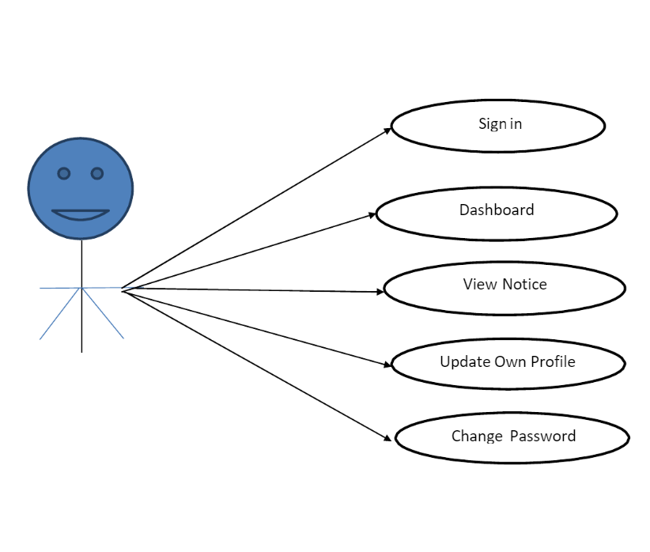

**Fig 3.1 Use Case Diagram for User**

**3.2.2 Admin**

.

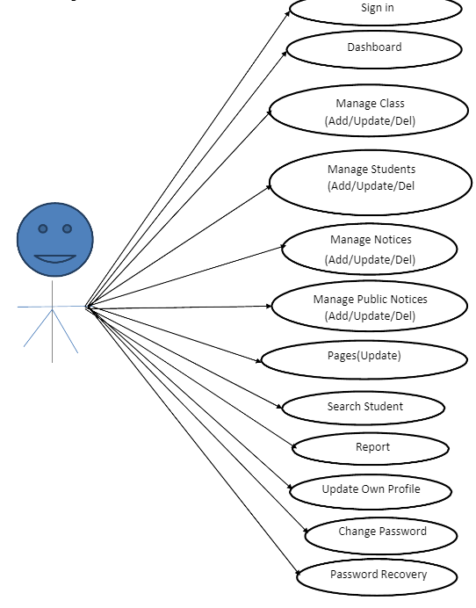

Fig. 3.2 Use Case Diagram for Admin

**3.3 ER Diagram**

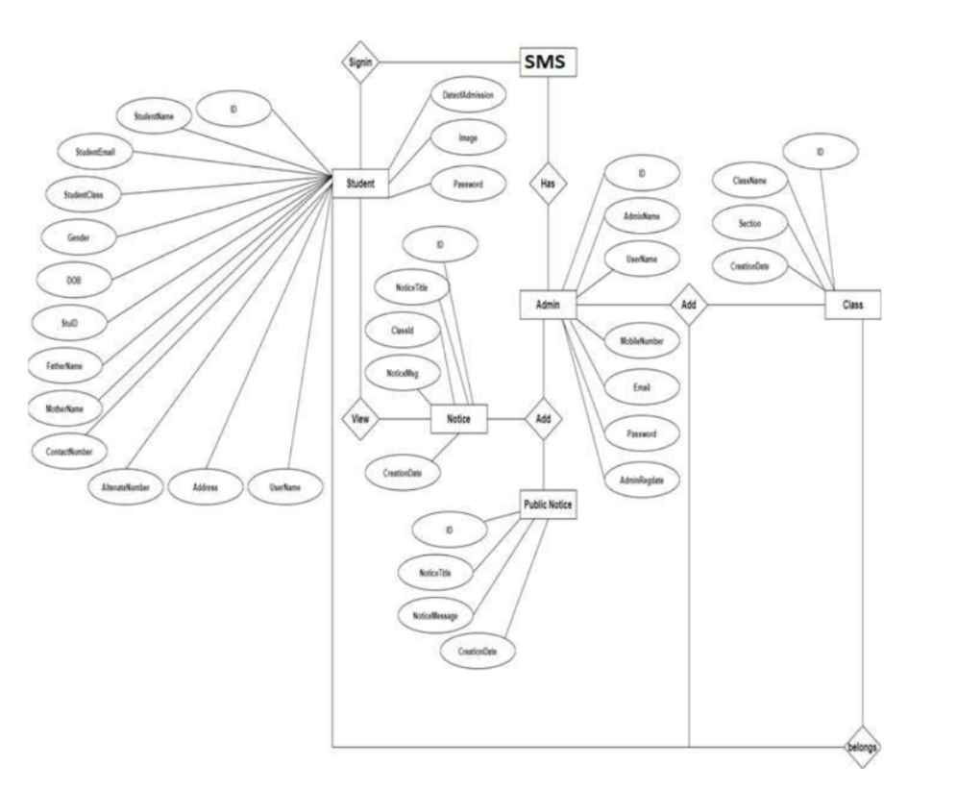

**Fig 3.3 E-R Diagram**

**3.3 Database Design**

The Student Management System has 6 MySQL tables

**3.3.1 tbladmin Structure:**

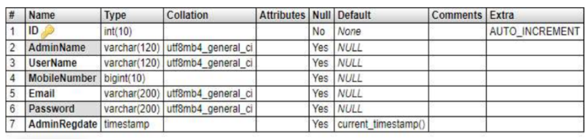

**3.3.2 tblclass Structure:**

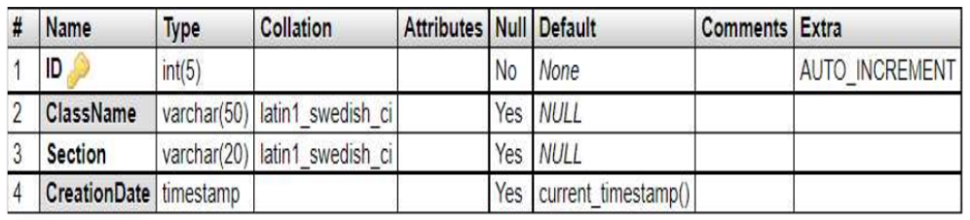

**3.3.3 tblnotice Structure:**

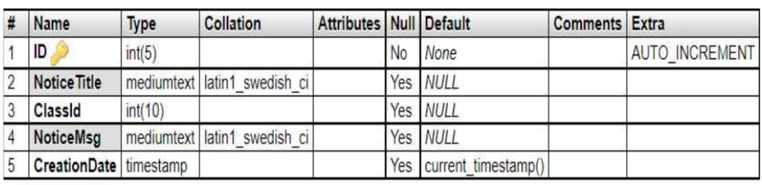

**3.3.4 tblpublicnotice Structure**

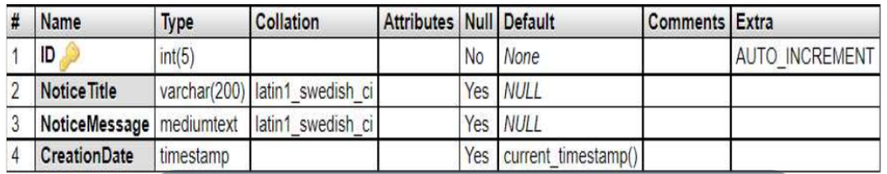

**3.3.5 tblstudent Structure**

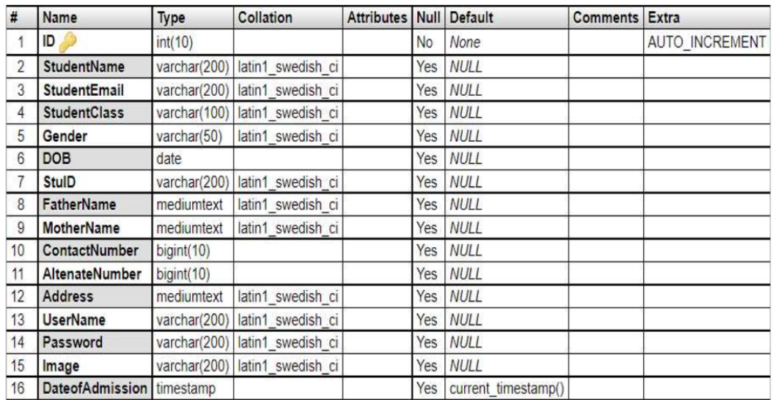

**3.3.6 tblpage Structure**

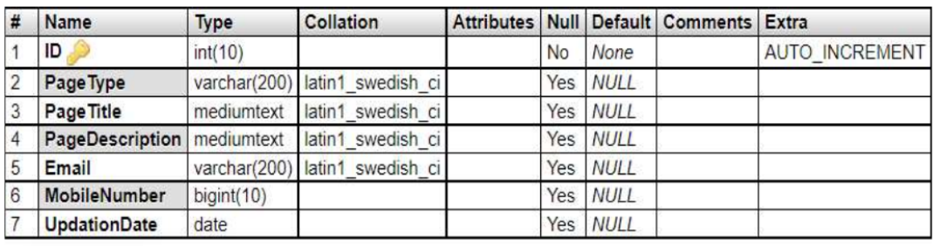

**3.3 Class Diagram**

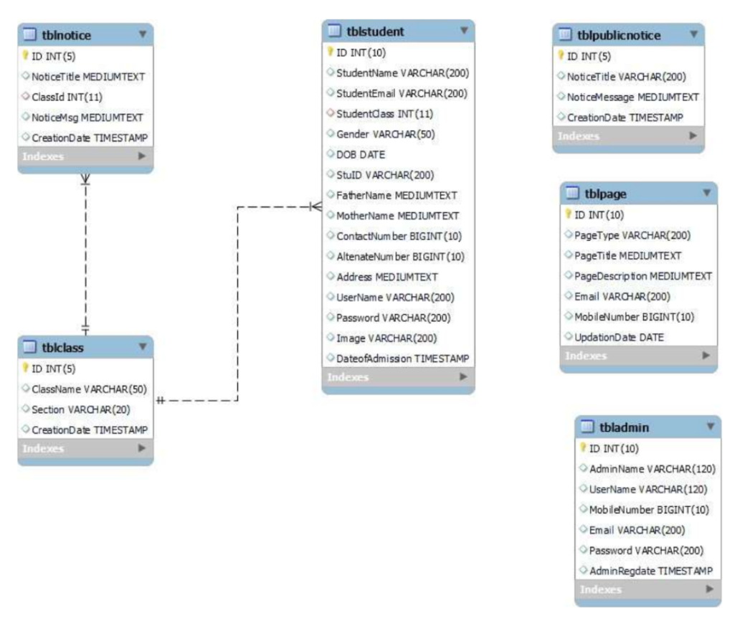

**Fig 3.4 Class Diagram**

E-R (Entity-Relationship) Diagram is used to represents the relationship

between entities in the table.

E-R (Entity-Relationship) Diagram is used to represents the relationship

between entities in the table.

**CHAPTER 4**

**TESTING**

Software testing is a critical element of the ultimate review of specification design and coding. Testing of software leads to the uncovering of errors in the software functional and performance requirements are met. Testing also provides a good indication of software reliability and software quality as a whole. The result of different phases of testing are evaluated and then compared with the expected results. If the errors are uncovered, they are debugged and corrected. A strategy approach to software testing has the generic characteristics:

* Testing begins at the module level and works “outwards” towards the integration of the entire computer-based system.
* Different testing techniques are appropriate at different points of time.
* Testing and debugging are different activities, but debugging must be accommodated in the testing strategy

### 4.1 UNIT TESTING

The module interface is tested to ensure that information properly flows into and out of the program unit under test. The unit testing is normally considered as an adjunct step to coding step. Because modules are not a standalone program, drivers and/or stubs software must be developed for each unit. A driver is nothing more than a “main program” that accepts test cases data and passes it to the module. A stub serves to replace the modules that are subordinate to the modules to be tested. A stub may do minimal data manipulation, prints verification of entry and returns.

Approaches used for Unit Testing were:

* **Functional Test**: Each part of the code was tested individually and the panels were tested individually on all platforms to see if they are working properly.
* **Performance Test:** These determined the amount of execution time spent on various parts of units and the resulting throughput, response time given by the module.
* **Stress Test:** A lot of test files were made to work at the same time in order to check how much workloads can the unit bear.
* **Structure Test**: These tests were made to check the internal logic of the program and traversing particular execution paths.

### 4.2 INTEGRATION TESTING

If they all work individually, they should work when we put them together. The problem of course is “putting them together”. This can be done in two ways:

**Top-down integration:** Modules are integrated by moving downwards through the control hierarchy, beginning with main control module are incorporated into the structure in either a depth first or breadth first manner.

**Bottom-up integration:** It begins with construction and testing with atomic modules i.e. modules at the lowest level of the program structure. Because modules are integrated from the bottom up, processing required for the modules subordinate to a given level is always available and the need of stubs is eliminated.

**Testing includes Verification and Validation**

**Verification:-**is a process of confirming that software meets its specification.

**Validation:**- is the process of confirming that software meets the customer’s requirements.

### 4.3 SYSTEM TESTING

System testing is a type of software testing that evaluates the overall functionality and performance of a complete and fully integrated software solution. It tests if the system meets the specified requirements and if it is suitable for delivery to the end-users. This type of testing is performed after the integration testing and before the acceptance testing.

System Testing is a type of software testing that is performed on a complete integrated system to evaluate the compliance of the system with the corresponding requirements. In system testing, integration testing passed components are taken as input. The goal of integration testing is to detect any irregularity between the units that are integrated together. System testing detects defects within both the integrated units and the whole system. The result of system testing is the observed behaviour of a component or a system when it is tested.

**System Testing Process:**

System Testing is performed in the following steps:

* Test Environment Setup: Create testing environment for the better quality testing.
* Create Test Case: Generate test case for the testing process.
* Create Test Data: Generate the data that is to be tested.
* Execute Test Case: After the generation of the test case and the test data, test cases are executed.
* Defect Reporting: Defects in the system are detected.
* Regression Testing: It is carried out to test the side effects of the testing process.
* Log Defects: Defects are fixed in this step.
* Retest: If the test is not successful then again test is performed.

### 4.4 ACCEPTANCE TESTING

It is formal testing according to user needs, requirements, and business processes conducted to determine whether a system satisfies the acceptance criteria or not and to enable the users, customers, or other authorized entities to determine whether to accept the system or not.

Acceptance Testing is the last phase of software testing performed after System Testing and before making the system available for actual use.

### 4.5 DEBUGGING

Debugging occurs as a consequence of successful testing i.e. when a test case uncovers an error, debugging is the process that results in identifying the location of error ad the removal of error. The poorly understood mental process that connects a symptom to cause is debugging. This process will always have one of the two outcomes.

* The cause will be found, corrected and then removed or
* The cause will not be found. In the latter case the person performing debugging may suspect a cause, design a test case to help validate his suspicion, and then work towards the correction of errors in the interactive fashion.

Following three approaches of debugging were used:

* Debugging by Induction
* Debugging by Deduction
* Backtracking

**In this project we mainly used PRINT STATEMENTS debugging technique**

**CHAPTER 5**

**RESULTS**

* 1. **Screens and Explanations**

This chapter will include all the screens available in the project such as home page, registration page, login page etc.

Screens available in the system are as follows:

**Screen 1: Home Page**

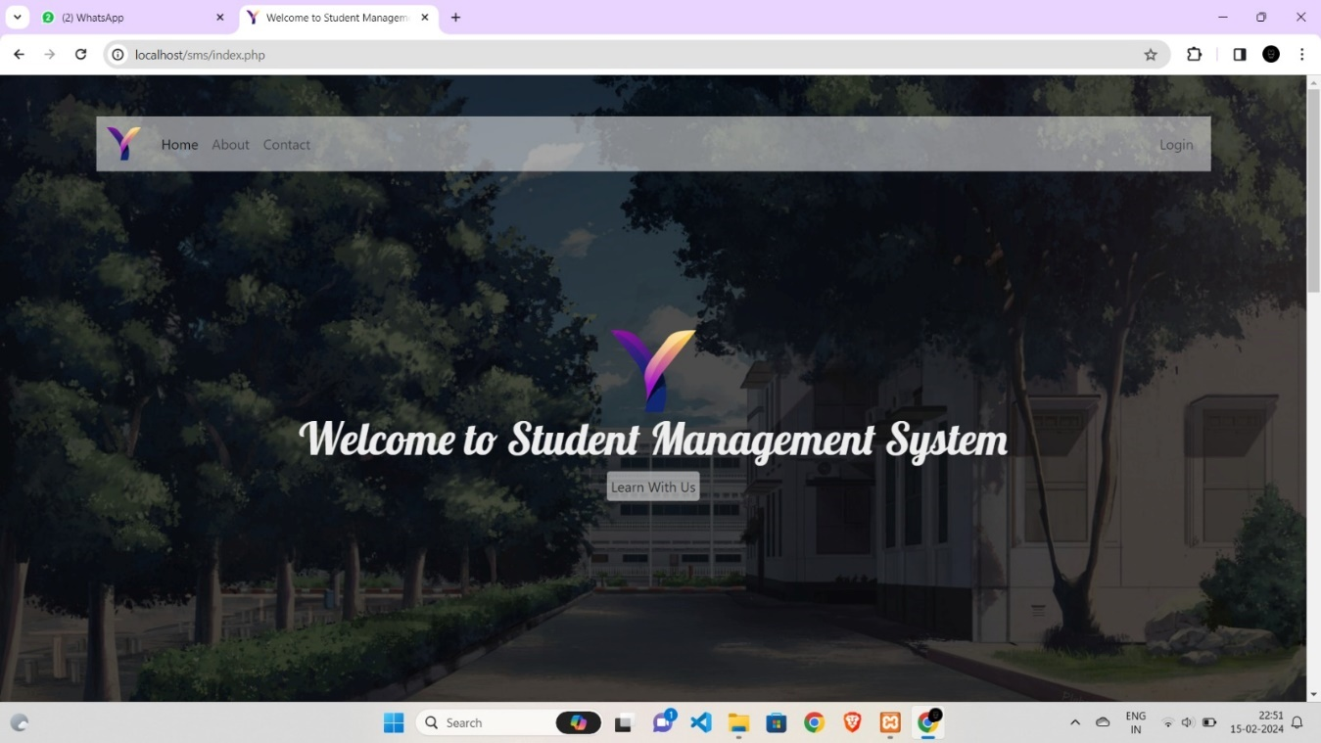

Fig. 5.1 Home Page

**Screen 2: About Us**

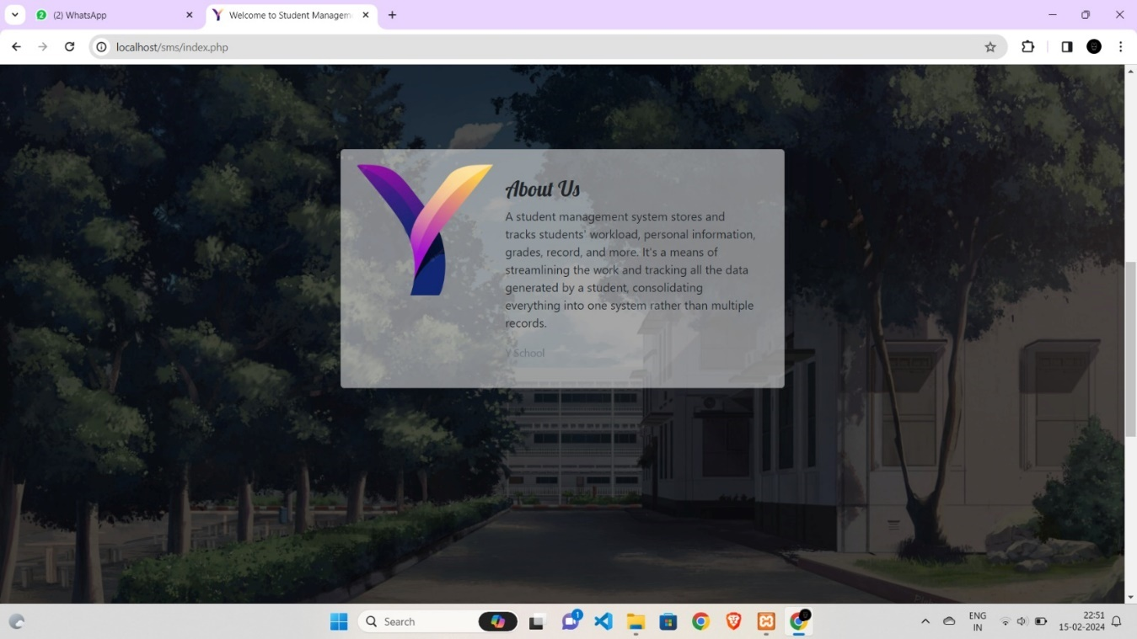

Fig. 5.2 About Us

**Screen 3: Login Page**

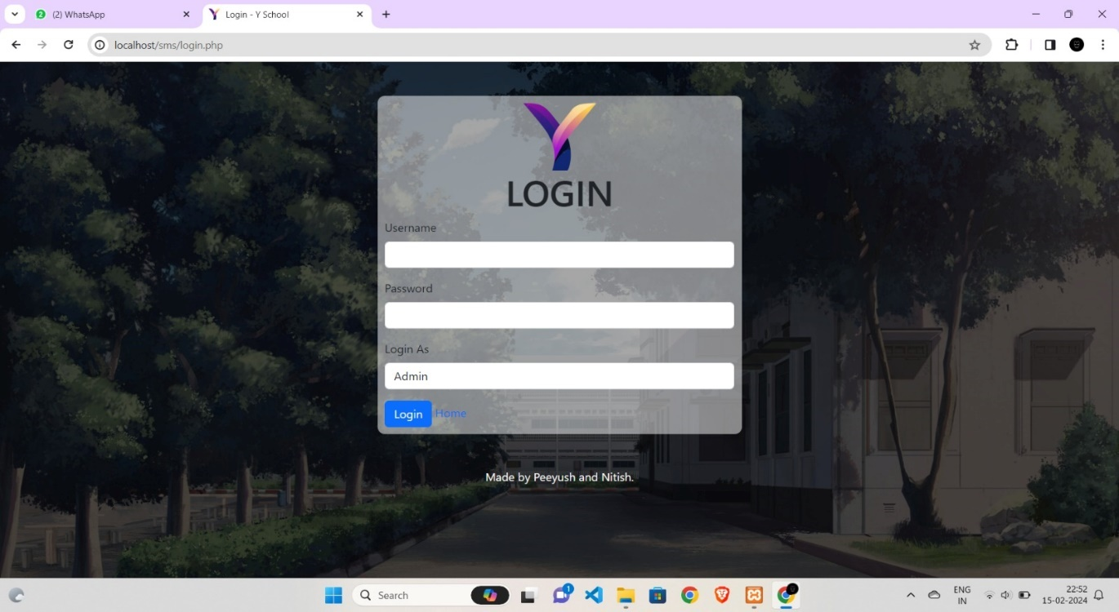

Fig. 5.3 Login Page

**Screen 4: Admin Dashboard**

.

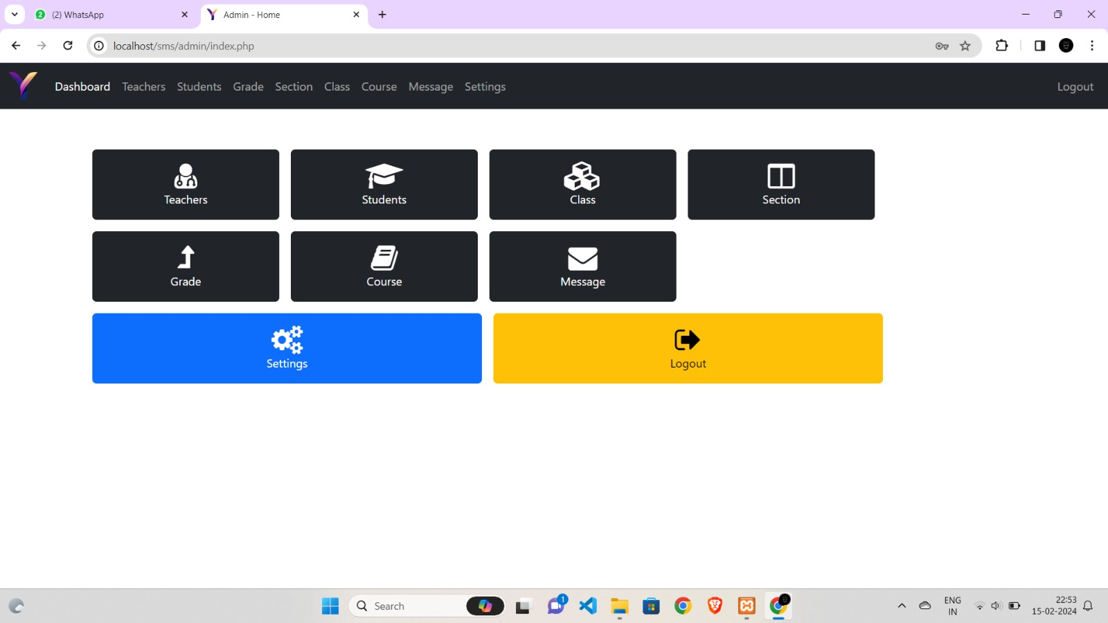

Fig. 5.4 Admin Dashboard

**Screen 5: View and Add Teacher**

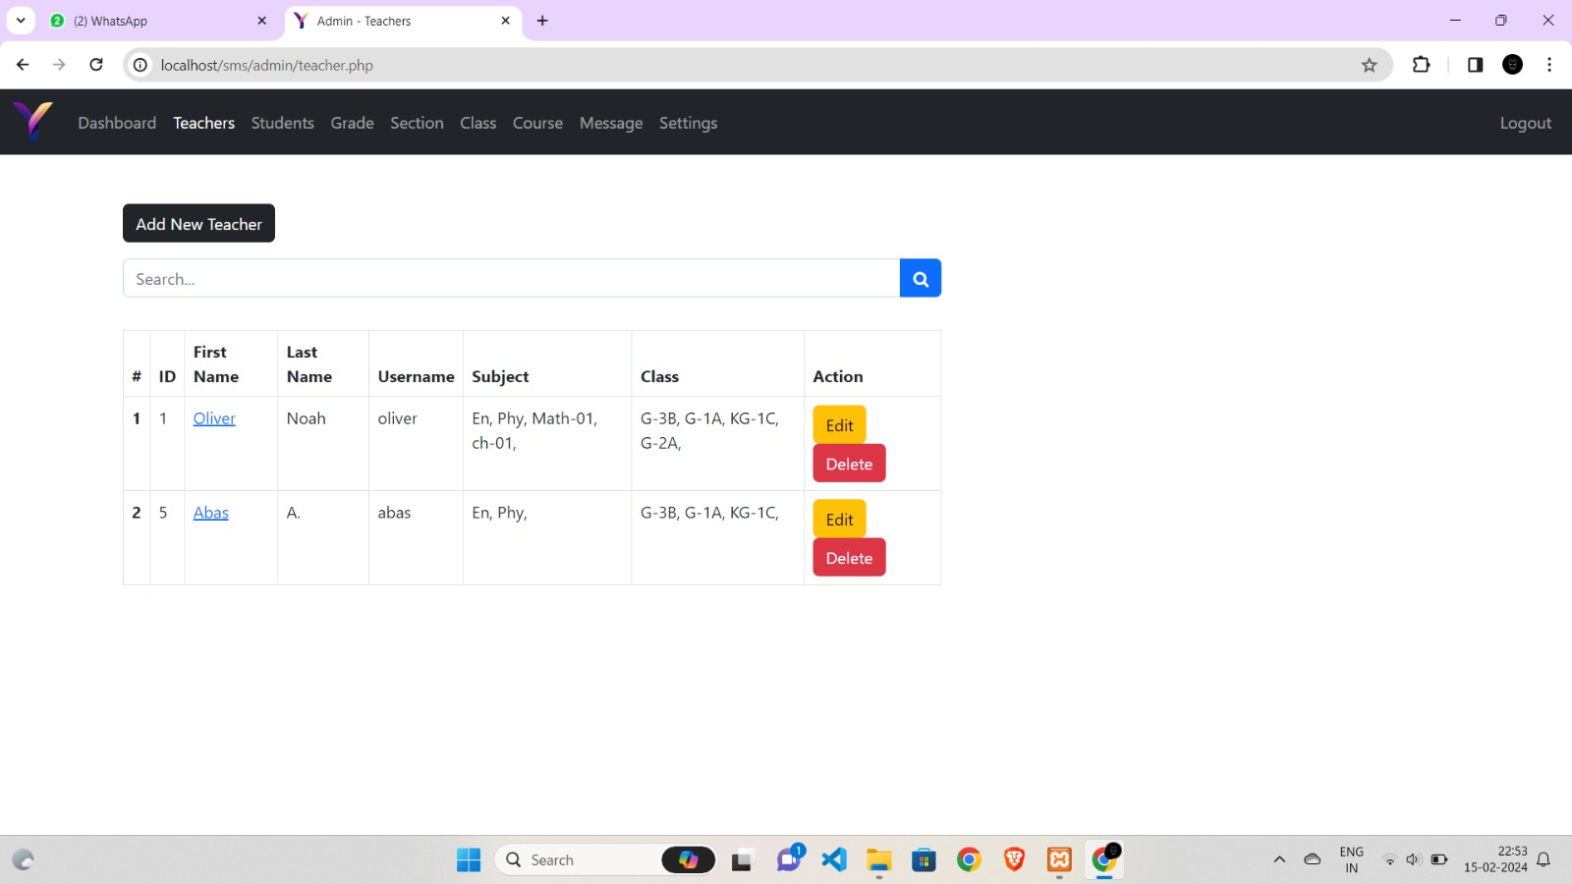

Fig. 5.5 View and Add Teacher

**Screen 6: View and Add Student**

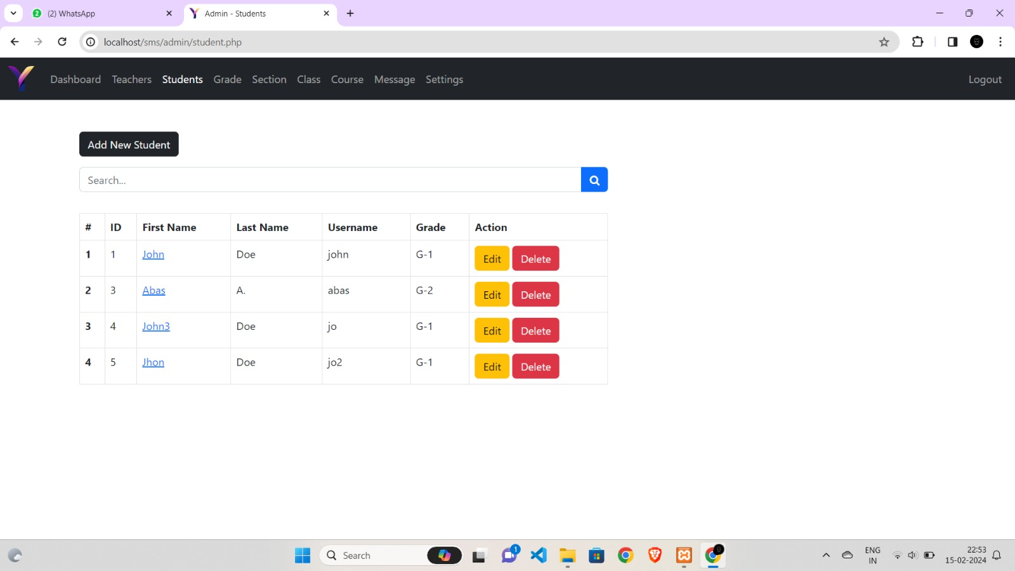

Fig. 5.6 View and Add Student

**Screen 7: Admin View of Grades**

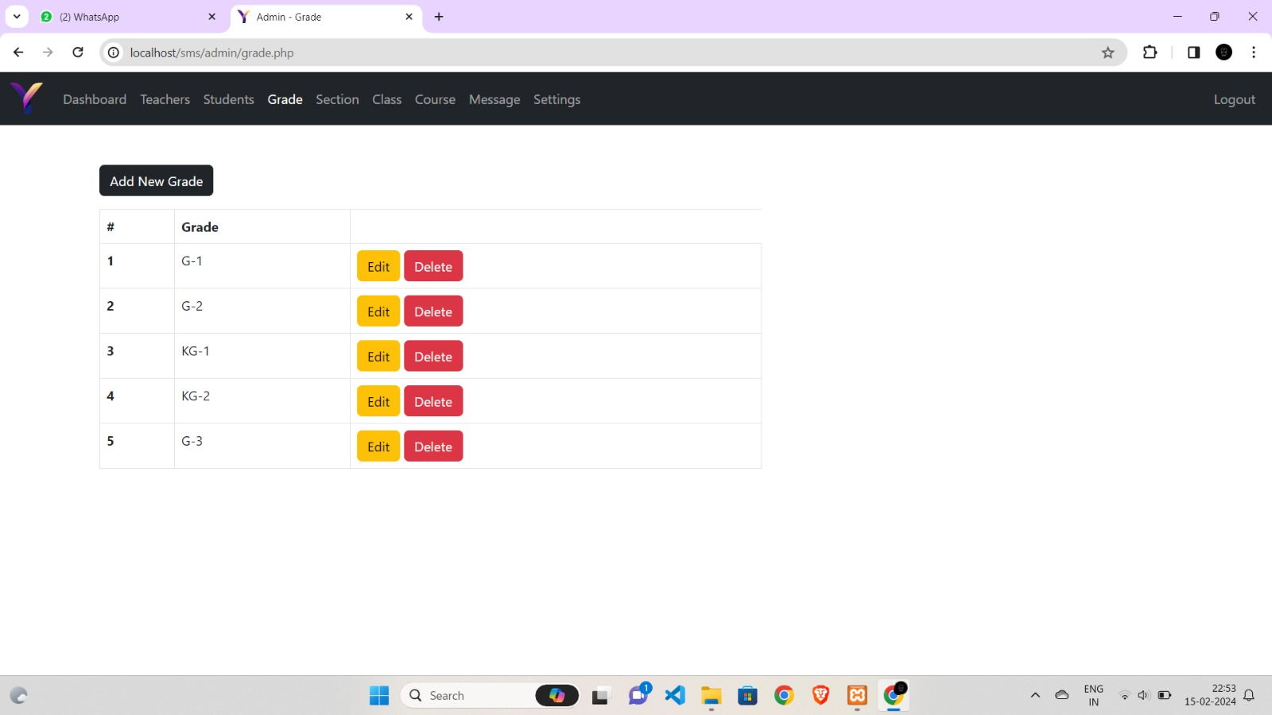

Fig. 5.7 View and Add Grade by Admin

**Screen 8: View and Add Class**

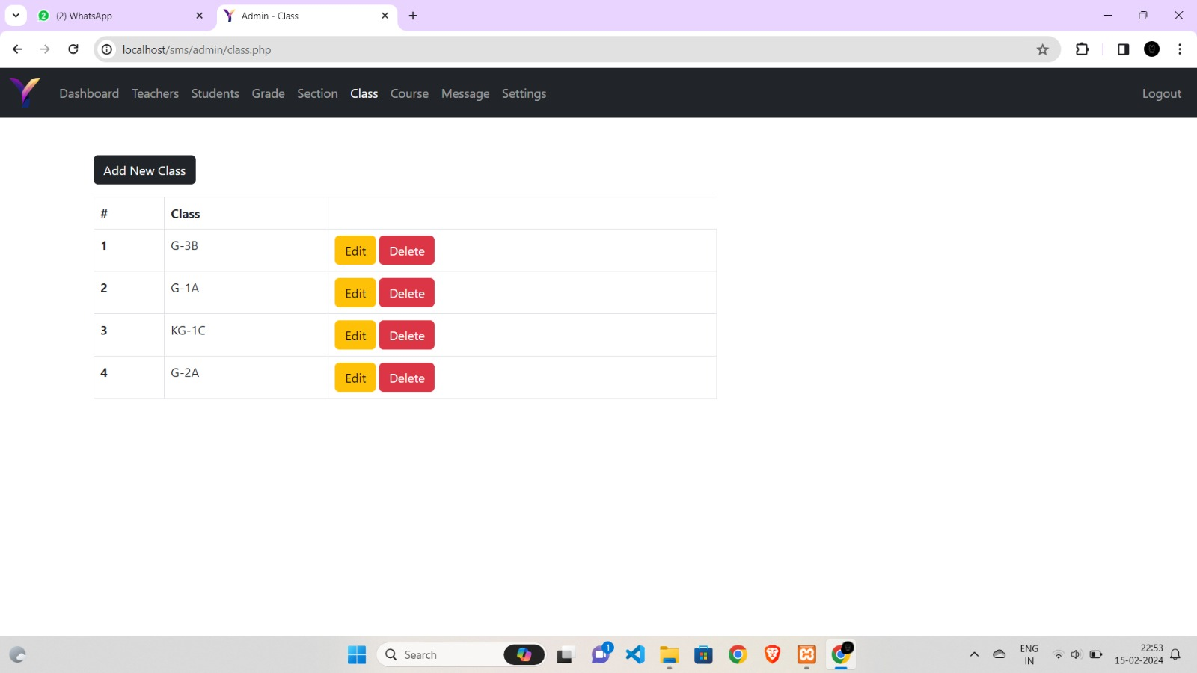

Fig. 5.8 View and Add Class

**Screen 9: View and Add Notices**

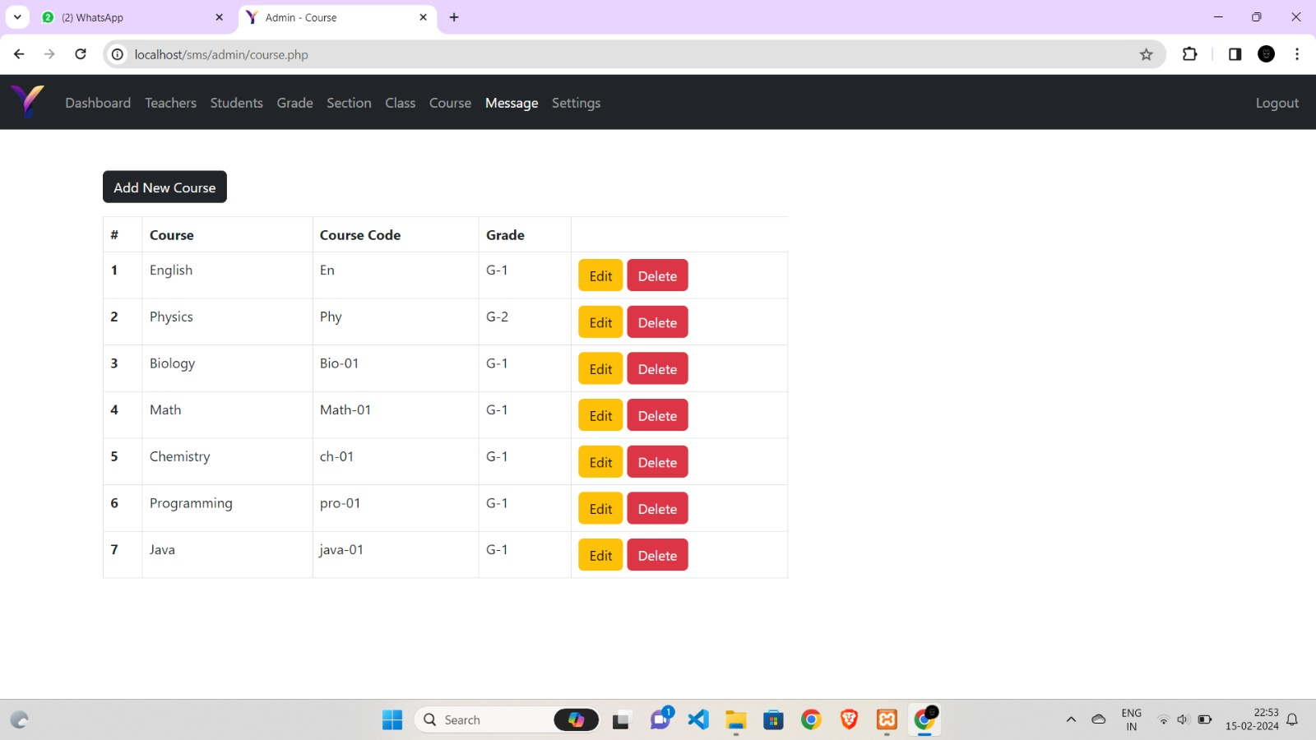

Fig. 5.9 View and Add Notices

**Screen 10: Edit Details of Courses**

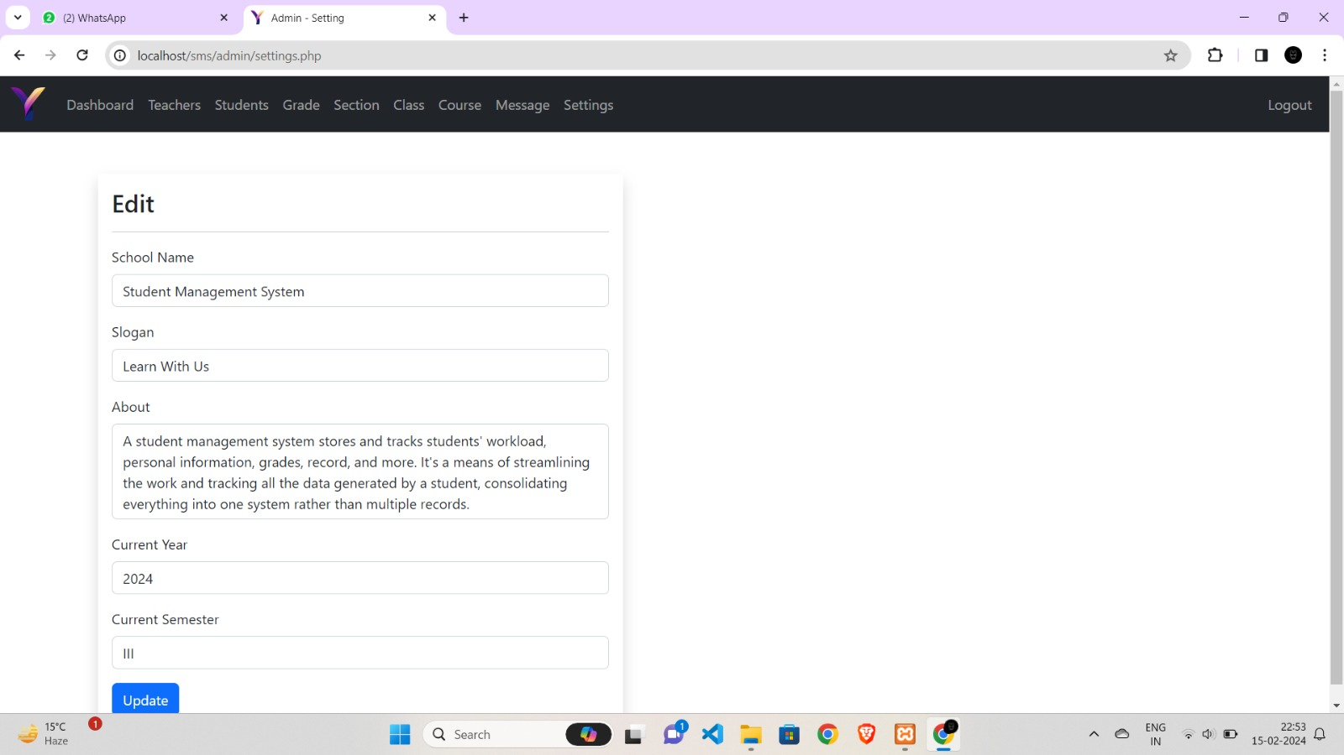

Fig. 5.10 Edit Courses

**Screen 11: Student Dashboard**

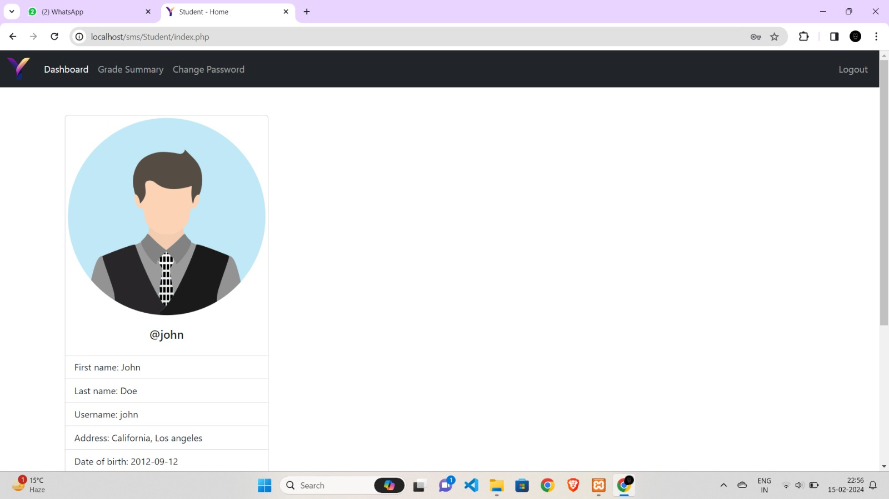

Fig. 5.11 Student Dashboard

**Screen 12: Student Grade Summary**

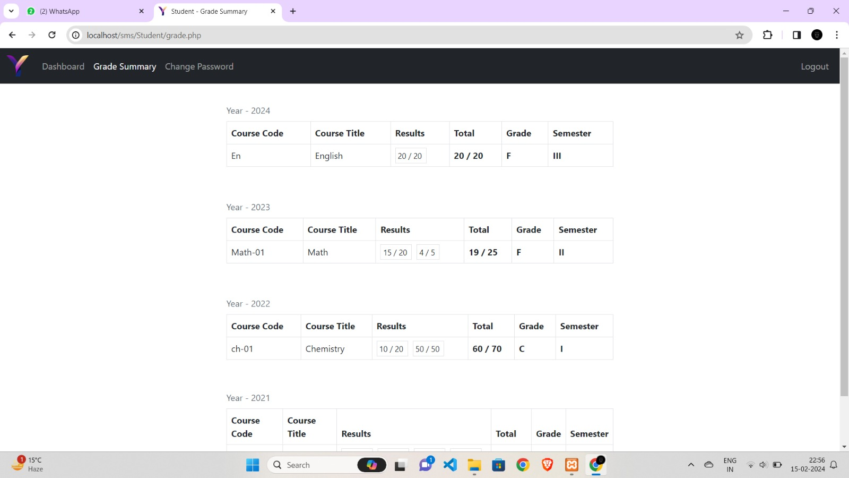

Fig. 5.12 Grade Summary

**Screen 13: Change Password (Student)**

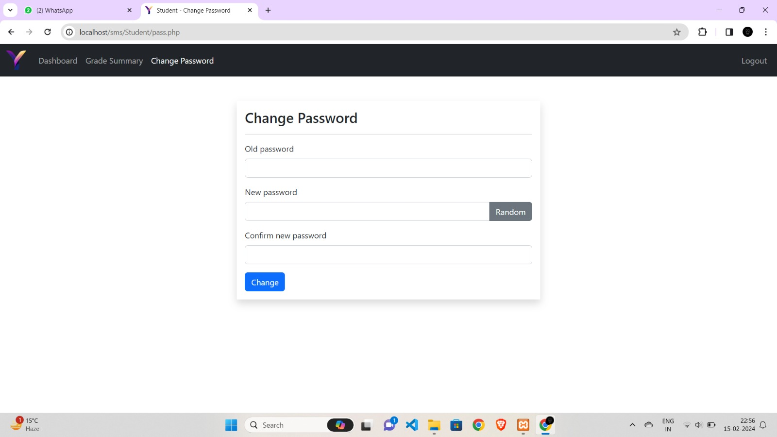Fig. 5.13 Change Student Password

**Screen 14: Teacher Dashboard**

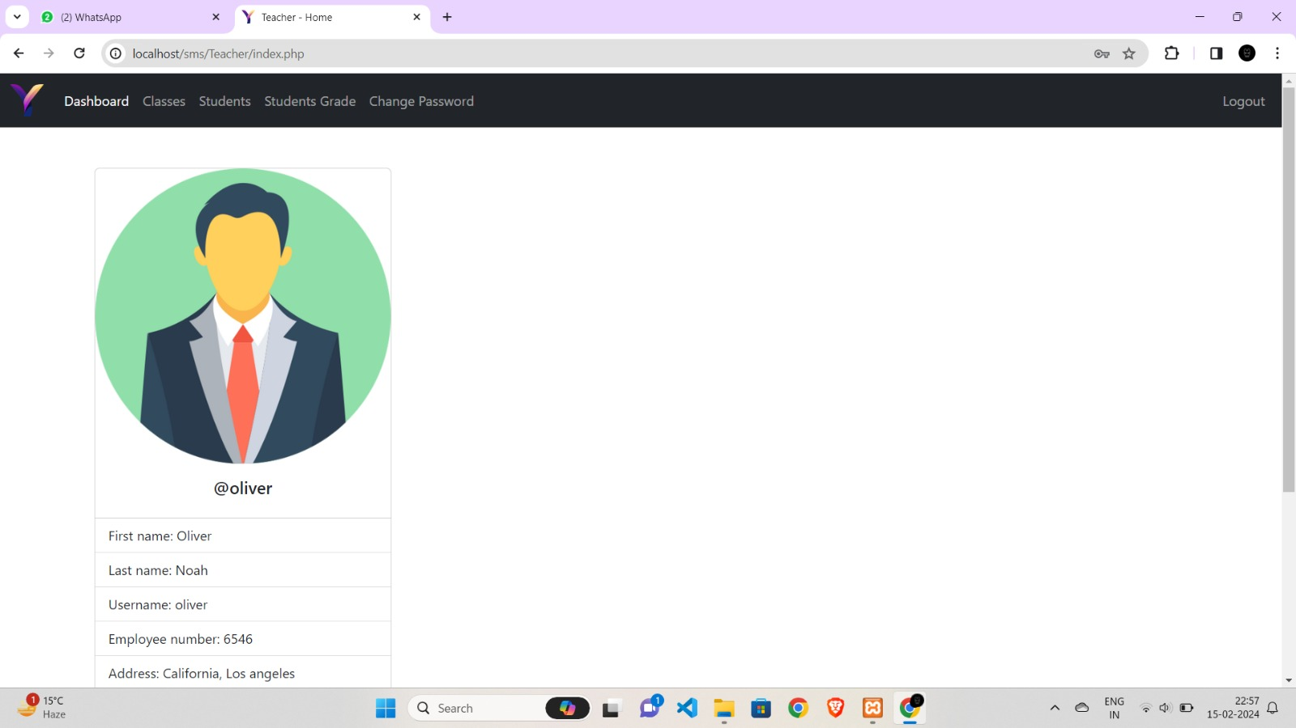

Fig. 5.14 Teacher Dashboard

**Screen 15: View Classes**

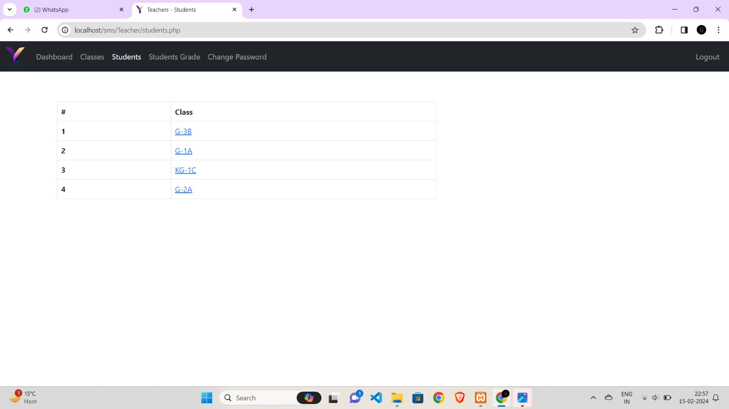

Fig. 5.15 View Classes

**Screen 16: View Students**

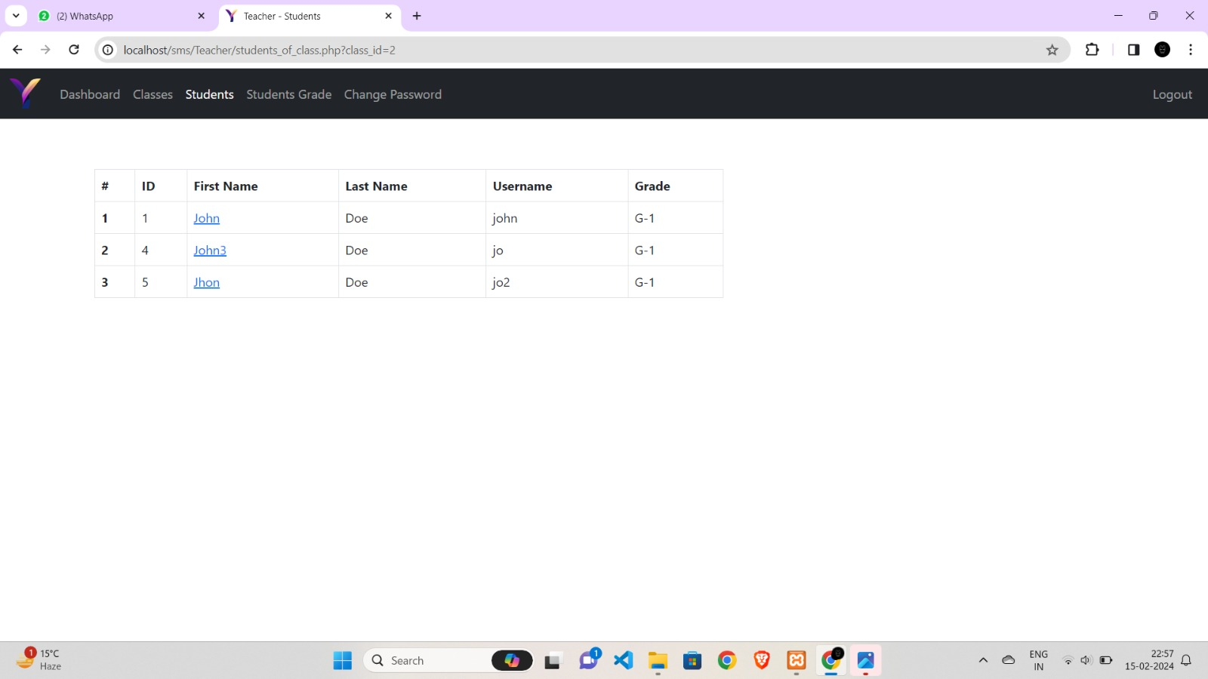

Fig. 5.16 View Students

**Screen 17: View Students Grades**

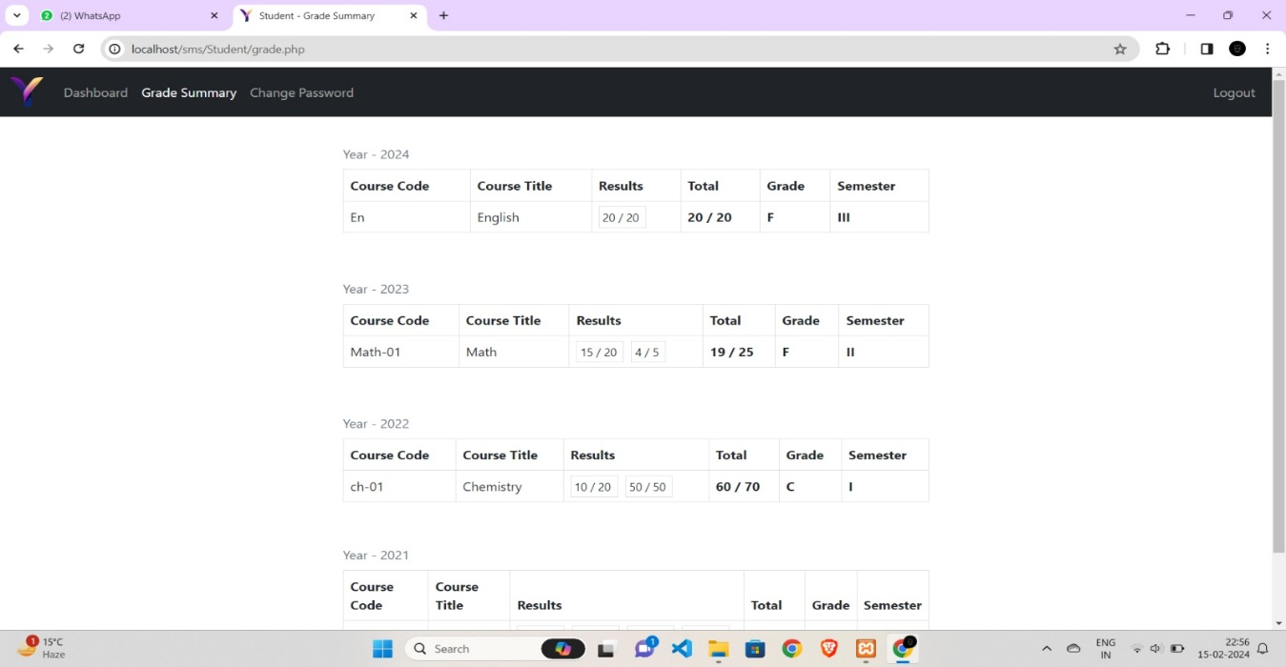

Fig. 5.17 View Students Grades

**Screen 18: Change Password for Teacher**

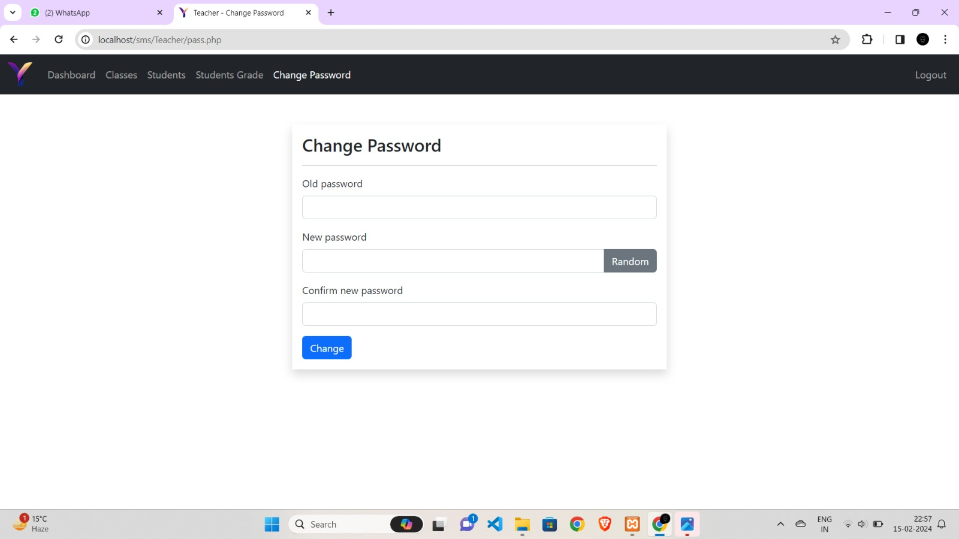

Fig. 5.18 Change Teacher’s Password

**CHAPTER 6**

**DISCUSSIONS**

The Discussions section of this report delves into crucial aspects of the Student Management System, shedding light on the strategic choices and implications for user experience, scalability, and future developments. The technological integration within the PHP is highlighted, emphasizing the deliberate use of MySQL for its flexibility and scalability.

**6.1 Performance**

Student Performance Management System is a management system for education establishments to manage student’s academics related data.

* It allows to store exam results and notify parents in case of low performance.
* It allows teachers to classify students according to their performance and take actions accordingly.
* Ensure data integrity, privacy and security

**6.2 Limitations of the System**

Student Management Systems (SMS) are software platforms designed to streamline administrative tasks related to managing student data in educational institutions. While these systems offer numerous benefits, they also have limitations that institutions should consider:

* **Cost:** Implementing and maintaining a robust SMS can be expensive, especially for smaller institutions with limited budgets. Costs can include software licenses, hardware infrastructure, staff training, and ongoing technical support.
* **Complexity:** Some SMS platforms can be complex to set up and customize according to the specific needs of an institution. This complexity may require significant time and resources to configure the system properly.
* **Technical Requirements**: SMS often require specific hardware and software infrastructure to run efficiently. Institutions may need to invest in servers, databases, and networking equipment to support the system, which can add to the overall cost and complexity.
* **Data Security and Privacy**: Storing sensitive student information in an SMS raises concerns about data security and privacy. Institutions must ensure that the system complies with relevant regulations (such as GDPR in Europe or FERPA in the United States) and implement robust security measures to protect student data from unauthorized access or breaches.
* **Integration Challenges:** Integrating an SMS with existing systems (such as learning management systems, finance software, or human resources systems) can be challenging. Incompatibilities between systems may require custom development or middleware solutions to facilitate data exchange and synchronization.
* **User Adoption:** Introducing a new SMS may face resistance from staff who are accustomed to legacy systems or manual processes. Adequate training and support are essential to encourage user adoption and maximize the system's benefits.
* **Scalability:** As institutions grow or change, the SMS must be able to scale to accommodate increased data volumes and additional functionality. Scalability limitations can hinder long-term use and require costly upgrades or migrations to more robust systems.
* **Customization Constraints:** While many SMS platforms offer customization options, there may be limitations on the extent to which the system can be tailored to meet the unique requirements of an institution. Customizations may also introduce additional complexity and maintenance overhead.
* **User Experience:** Despite advancements in user interface design, some SMS platforms may still suffer from usability issues that impact the user experience for administrators, teachers, students, and parents. Poorly designed interfaces can lead to frustration, inefficiency, and reduced productivity.

**6.3 Future Research Directions**

The future scope of Student Management Systems (SMS) is broad and promising, driven by advancements in technology and evolving educational needs. Some potential future developments and trends in SMS include:

* **Artificial Intelligence (AI) Integration**: AI can enhance various aspects of SMS, including personalized learning experiences, predictive analytics for student success, automated administrative tasks such as grading and scheduling, and intelligent chatbots for student support.
* **Data Analytics and Predictive Modeling:** SMS can leverage big data analytics and predictive modeling techniques to identify patterns, trends, and insights from student data. This information can be used to optimize curriculum design, improve teaching strategies, and intervene early to support at-risk students.
* **Mobile Accessibility:** With the proliferation of mobile devices, SMS platforms will continue to prioritize mobile accessibility, allowing students, parents, teachers, and administrators to access information and perform tasks on the go through dedicated mobile apps or responsive web interfaces.
* **Blockchain for Academic Credentials:** Blockchain technology holds the potential to revolutionize academic credential verification and secure student records. By using blockchain-based systems, institutions can ensure the integrity and authenticity of academic credentials, simplifying the verification process for employers and educational institutions.
* **Interoperability and Standards:** There is a growing emphasis on interoperability and data standards within educational technology ecosystems. Future SMS platforms are likely to prioritize interoperability with other systems, allowing seamless integration with learning management systems, assessment tools, and educational apps.
* **Personalized Learning Paths**: SMS can facilitate personalized learning paths tailored to individual student needs, preferences, and learning styles. Adaptive learning algorithms can dynamically adjust course content, pace, and assessment based on student performance and feedback.
* **Enhanced Communication and Collaboration Tools:** Future SMS platforms may incorporate advanced communication and collaboration tools to facilitate seamless interaction between students, teachers, parents, and administrators. Features such as real-time messaging, video conferencing, and collaborative project management can foster a more connected learning community.
* **Accessibility and Inclusivity**: There is a growing awareness of the importance of accessibility and inclusivity in educational technology. Future SMS platforms will prioritize accessibility features to ensure that all students, including those with disabilities, can access and benefit from the system's functionalities.
* **Gamification and Engagement Strategies:** Gamification elements can be integrated into SMS to enhance student engagement, motivation, and participation. By incorporating game-like mechanics such as points, badges, and leaderboards, SMS platforms can make learning more interactive and enjoyable.
* **Globalization and Multilingual Support:** As educational institutions become increasingly globalized, future SMS platforms will need to support multiple languages and accommodate diverse cultural contexts. Multilingual interfaces and localization features will be essential for serving diverse student populations worldwide.

Overall, the future scope of Student Management Systems is characterized by innovation, customization, and a focus on improving learning outcomes and administrative efficiency in educational institutions. By embracing emerging technologies and addressing evolving educational needs, SMS platforms will continue to play a vital role in shaping the future of education.

**CHAPTER 7**

**CONCLUSION**

In conclusion, Student Management Systems (SMS) represent a crucial component of modern educational infrastructure, streamlining administrative tasks, improving communication, and enhancing learning experiences for students, teachers, parents, and administrators. As educational institutions navigate the complexities of the digital age, SMS platforms offer a comprehensive solution to manage student data, academic resources, and administrative processes effectively.

Despite facing certain limitations such as cost, complexity, and technical challenges, the future scope of SMS is promising. Emerging technologies like artificial intelligence, blockchain, and mobile accessibility are poised to revolutionize how educational institutions manage student information, deliver personalized learning experiences, and promote collaboration among stakeholders.

Moving forward, it's essential for educational institutions to prioritize interoperability, data security, accessibility, and inclusivity when selecting and implementing SMS platforms. By embracing innovation and addressing the evolving needs of diverse student populations, SMS will continue to play a pivotal role in shaping the future of education, driving improvements in student outcomes, institutional efficiency, and overall educational quality.

The Student Management System (SMS) stands as a cornerstone in the digital transformation of educational institutions, offering a multifaceted solution to the myriad challenges they face. By centralizing student data, automating administrative tasks, and fostering collaboration among stakeholders, SMS platforms empower institutions to optimize resource allocation, enhance educational experiences, and ultimately improve student outcomes.

While SMS platforms may encounter limitations such as initial implementation costs, technical complexities, and the need for ongoing user training, these challenges are outweighed by the significant benefits they provide. Looking ahead, the future of SMS is marked by a convergence of cutting-edge technologies, including artificial intelligence, big data analytics, and blockchain, which promise to further revolutionize how educational institutions operate and engage with their students.

Moreover, as educational landscapes continue to evolve in response to global trends, such as the rise of remote learning and the growing emphasis on personalized education, SMS platforms are poised to adapt and innovate accordingly. By prioritizing flexibility, scalability, and user-centric design, SMS vendors can ensure that their platforms remain agile enough to meet the evolving needs of diverse educational ecosystems worldwide.

In essence, the Student Management System represents not just a tool for administrative efficiency, but a catalyst for educational transformation. As institutions embrace the potential of SMS to drive innovation, foster inclusivity, and empower learners, they pave the way for a future where education is more accessible, engaging, and impactful than ever before.

**CHAPTER 8**

**BIBLIOGRAPHY**

* Smith, J. (2020). "The Role of Student Management Systems in Educational Institutions." Journal of Educational Technology, 25(2), 45-60.
* Johnson, A., & Lee, M. (2019). "Implementing a Student Management System: Challenges and Solutions." Proceedings of the International Conference on Educational Technology (ICET), 102-115.
* Educational Technology Research and Development Association. (2021). "Trends in Student Management Systems: Insights from Industry Reports." Retrieved from http://www.etrda.org/reports/trends-in-sms
* Brown, C. (2018). "Student Management Systems: A Comprehensive Guide." New York: Academic Press.
* Educational Systems Consultants. (2022). "Best Practices for Selecting and Implementing Student Management Systems: A White Paper." Retrieved from http://www.esc.com/whitepapers/best-practices-sms
* National Center for Education Statistics. (2020). "Data Security and Privacy Considerations in Student Management Systems: A Report." Retrieved from http://nces.ed.gov/reports/data-security-sms
* Educational Technology Association. (2023). "Case Studies in Student Management System Implementation: Lessons Learned and Success Stories." Retrieved from http://www.edutechassoc.org/case-studies/sms-implementation
* Adams, R., & Wilson, L. (2017). "The Future of Student Management Systems: Emerging Trends and Technologies." Journal of Educational Technology & Society, 30(4), 78-92.
* International Conference on Educational Technology. (2019). Proceedings of the International Conference on Educational Technology (ICET). Retrieved from <http://www.icetconference.org/proceedings>

**CHAPTER 9**

**REFERENCES**

[1] Ritvars Bregzis, Calvin Gotlieb, Carole Moore. The Beginning of Automation in the University of Toronto Library, 1963-1972, in IEEE Annals of the History of Computing, 2002. [2] Prof. Godswill Obioma, Prof. Ismail Junaidu, Dr. Grace Ajagun. The Automation of Educational Assessment in Nigeria: Challenges and Implications for Pre-service Teacher Education, 39th Annual Conference of the International Association for Educational Assessment.

[3] Jou M, Shiau JK, Zhang HW. Application of Web Technologies in Automation Technology Education. International Journal of Computers and Applications. 2009; 31:4.

[4] Xiang Fu, Boris Peltsverger, Kai Qian, Lixin Tao, Jigang Liu. APOGEE – Automated Project Grading and Instant Feedback System for Web Based Computing, Computer Science and Information Technology, 2nd IEEE International Conference, 2009.

[5] Gerald Weber. Defining the Paperless Workplace with the Paper Metaphor-Not a Contradiction in Terms, Conference: Proceedings of the Fourth Australasian Workshop on Health Informatics and Knowledge Management, 120.

[6] Prita Patil, Kavita Shirsat. An Integrated Automated Paperless Academic Module for Education Institutes, International Journal of Engineering Science Invention Research & Development. 2015; I:IX.

[7] Sarthak Langde, Avinash Maurya, Tanvi Nakhawa, Anurag Sinha, Smita Patil, Kriti Karanam and Harshali Mugutrao. Automated Attendance System, International Journal of Applied Research. 2018; 248- 249.

[8] Saurabh Walia et al, International Journal of Computer Science and Mobile Computing, Vol.3 Issue.8, August- 2014, pg. 24-33

[9] Prabhu T Kannan, Srividya K Bansal,"Unimate: A Student Information System",2013 International Conference on Advances in Computing, Communications and Informatics (ICACCI)-p-1251- 1256

[10] Suraj Kishor Desai, Shahrukh Attar, Sonali Haridas Mane, Kalyan Bandu Dethe and Archana Lomte. Online